**ACTIVITY C:   
LANDCOVER POINTS**

GEP works with the Land Resources Division in supporting landcover models and mapping for our SPC member countries. In order to do this we rely on ground cover data points that shed light on a range of areas including deforestation, mineral extraction (working with georesources), crop cycles, urban expansion and coastal habitats.

Through this activity, you will use the QField app to collect data on different categories of landcover:

Remote points:

1. building – can be done remotely by moving the screen centre target to any rooftop (settlements, towns, hotels)
2. road – can be done remotely by moving the screen centre target to paved areas (be wary of oncoming traffic)

Walk to this landcover and stand here so that your GPS point is recorded:

1. forest – stand near a tree of any kind and save a point (watch out for falling coconuts!)
2. sand – should not be hard to find some stand – record a point
3. water – walk to the waters edge to record your point

At least three people on the team need to collect the five points so you may wish to work in pairs. After collecting all the points return to the EOO team member in zone C. After the facilitator reviews and approves your answers on QField you may retrieve the pink ribbon.

As the EOO team member to take a picture with your whole team holding the pink ribbon before progressing to the next stage.

**QFIELD INSTRUCTIONS**

1. Open your QField app (with internet) to load your basemap – zoom in and out to make sure the map is loaded at various scales.
2. 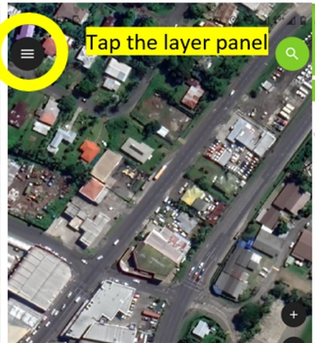Once the satellite basemap is loaded, you can work offline or online.
3. Tap the black circle in the top left of the screen to open the list of layers > tap the ‘activity_a_building_flood_risk’ layer
4. A screenshot of a phone

   Description automatically generatedThen select the pencil to make sure you are able to add new data points. Then tap on the map to bring the map display back.
5. Zoom in on your location (the blue dot) – you can tap the bottom right green button to add a new point at the centre of your target in the middle of your screen to add a new point on the building of interest.
6. Choose one of the five land cover categories from the drop down list then tap the white tick on the green banner at the top of the form.

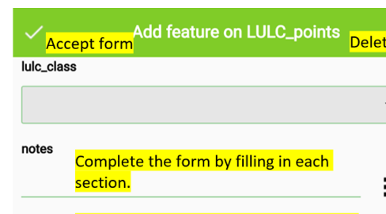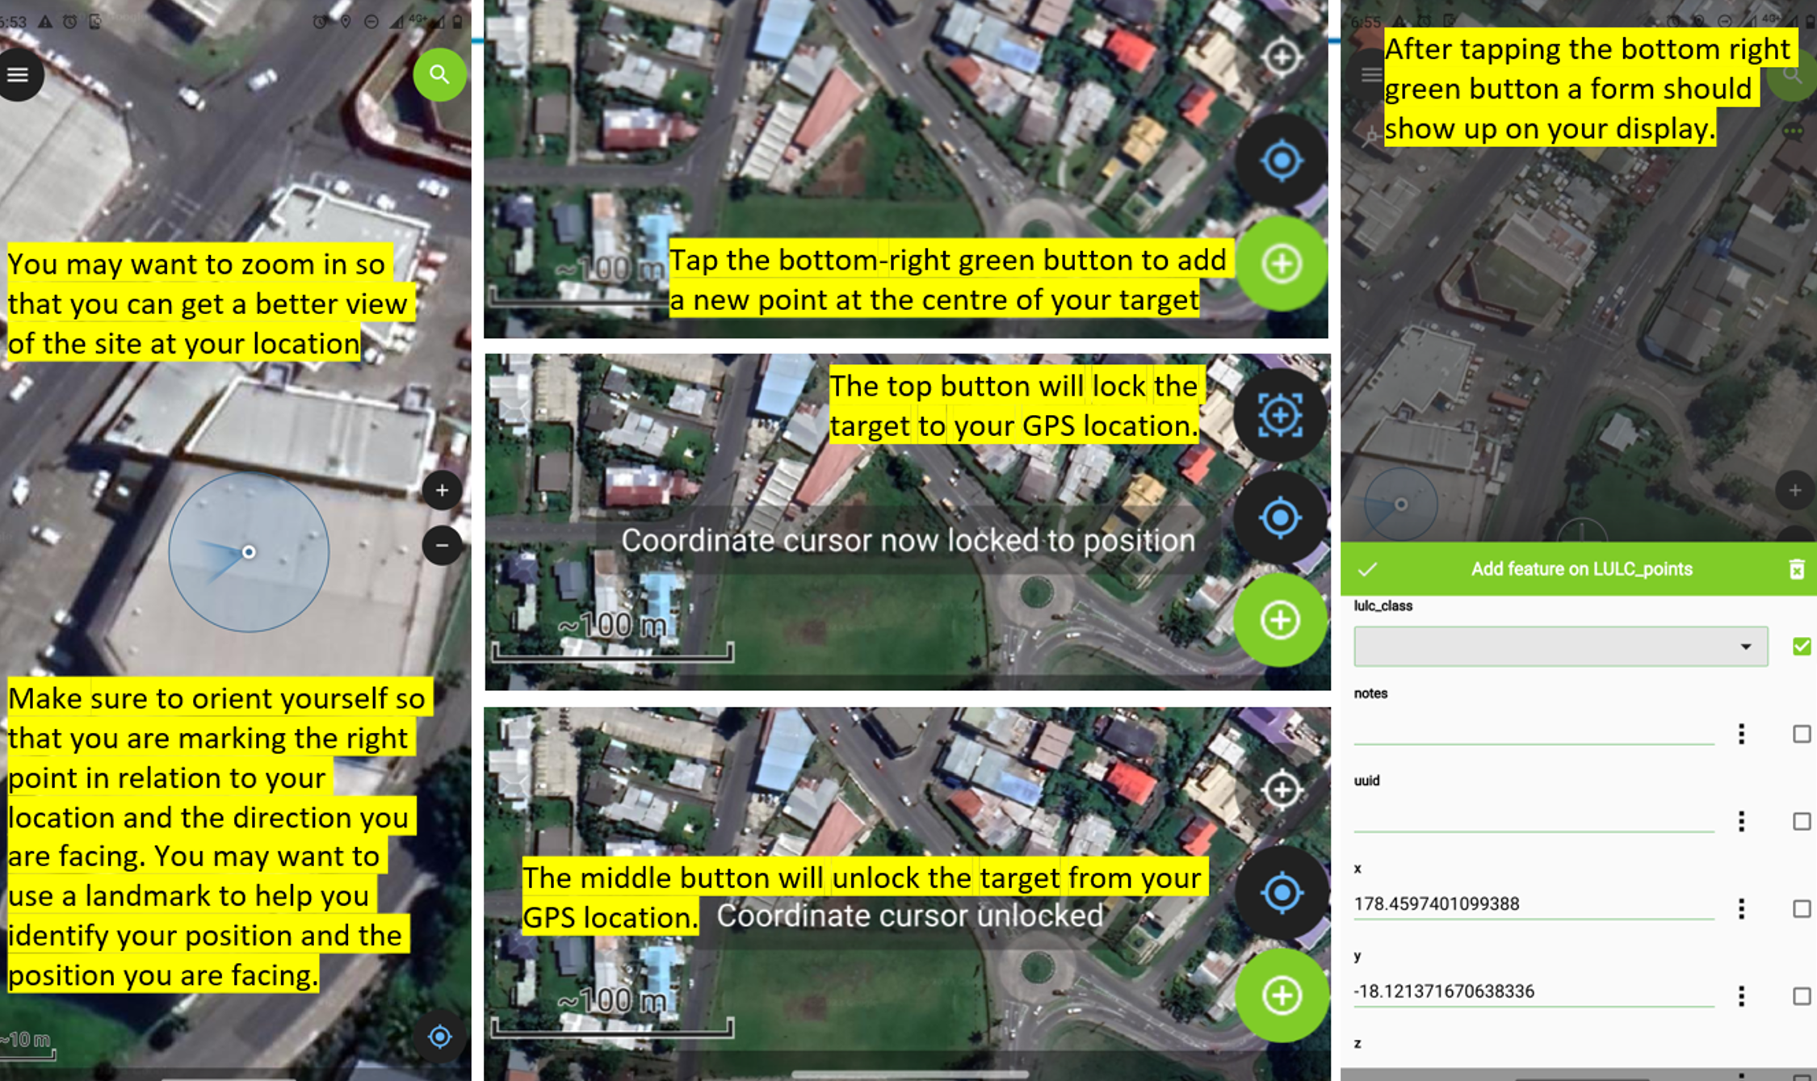

If you are stuck, you can also ask for help from the EOO team member facilitating this activity or see steps 2-4 in the QField reference sheet.